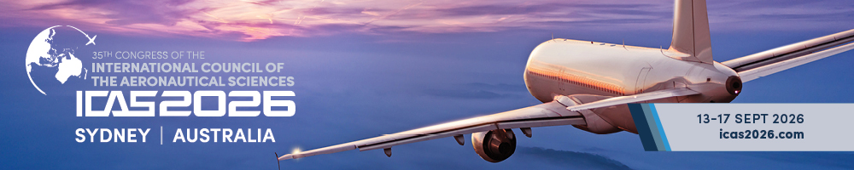
LOW BOOM DESIGN AND ANALYSIS OF A BLENDED-WING-BODY CONFIGURATION FOR LARGE-SIZED SUPERSONIC TRANSPORT
Lin Yi1,2, Zhang Keshi,2,*, Han Zhonghua1,2, Chen Qing1,2
1School of Aeronautics, Northwestern Polytechnical University, Xi’an, 710072, PR China
2National Key Laboratory of Aircraft Configuration Design, Xi’an, 710072, PR China

Abstract
The development of next-generation supersonic transport (SST) represents a critical direction for future civil aviation. However, most existing SST configurations feature small passenger capacity, which greatly limits their commercial application potential. The fuselage volume of the conventional tube-and-wing (TAW) layout increases quadratically with passenger seating density. In contrast, the blended-wing-body (BWB) geometry can closely conform to the cabin contour, yielding a much smaller volume penalty as passenger capacity increases. For the development of large-scale SST, an advanced configuration is expected to achieve either lower sonic boom at the same passenger capacity or higher seating capacity under the same sonic boom constraint. Accordingly, a 160-seat large supersonic blended-wing-body (SBWB) configuration is proposed in this paper, and a dedicated parametric modeling method is established to generate the baseline configuration under cabin volume constraints. To characterize the sonic boom performance of the large SBWB, systematic analyses are conducted on both fore-body and rear-body waveform. The Jones–Seebass–George–Darden (JSGD) inverse design method is adopted for fore-body waveform optimization, reducing the ground perceived loudness level (PLdB) of the SBWB by 6.46. Rear-body analysis reveals prominent over-expansion phenomena for large-sized SBWB, which restricts further sonic boom reduction. Therefore, the regulation effect of aerodynamic auxiliary components on the aft waveform is investigated. The results indicate that winglets can effectively weaken the intensity of rear-body over-expansion and deliver waveform regulation benefits to a certain degree, while the control effect of V-tails is rather limited, the sonic boom intensity is further reduced to 98.7PLdB. Overall, the 160-seat SBWB exhibits aerodynamic advantages including a low cruise angle of attack and a broad lift distribution and demonstrates promising low-boom potential at large passenger capacity, providing a reference for the low-boom design of future large-capacity SST configurations.
Keywords: supersonic transport, blended-wing-body, sonic boom, aircraft design.

Introduction
Faster travel speed is an eternal pursuit of humanity. The flight speed of supersonic transport is twice that of traditional subsonic airliners or even higher, which can greatly improve travel efficiency and facilitate global economic and cultural exchanges. Hence, the new-generation SST represents a core technological frontier in the aviation industry of the 21st century^{[1-2]}. In its aviation strategic plan released in 2023, NASA stated that "the development of efficient, economical and eco-friendly supersonic commercial transportation will become a gamechanger for intercontinental travel in the future"^{[3]}. In 2025, the White House signed a presidential executive order titled "Leading the World in Supersonic Flight" to boost the development of domestic supersonic civil air transportation.
Nevertheless, excessive sonic boom remains the core bottleneck restricting the revival of supersonic transport. The first-generation supersonic airliners represented by Concorde and Tu-144 produced ground sonic boom up to 105 PLdB. International aviation authorities including FAA and EASA explicitly banned supersonic civil flight over land, which eventually led to their complete withdrawal from service^{[4]}. To accelerate the commercial comeback of supersonic transport, numerous countries have launched research programs for new-generation supersonic transport in several decades, and proposed a series of advanced low-boom configuration (as shown in Figure 1), such as NASA X-59^{[5]}, Lockheed Martin QSTA^{[6]}, TsAGI Strizh of Russia^{[7]} and JAXA S4 of Japan^{[8]}. After decades of continuous research, low sonic boom design technologies have achieved substantial progress, and a variety of mature and effective design methodologies have been established.
a. X-59 (America - NASA)  1-seat, 75 PLdB | b. QSTA (America - Lockheed Martin)  40-seat, 80 PLdB
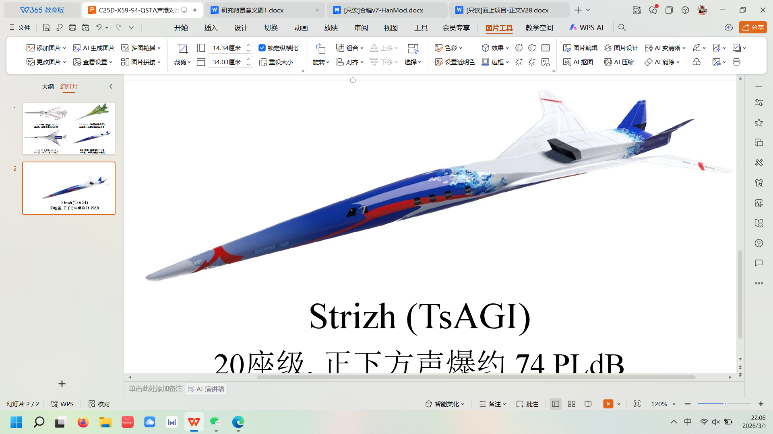
c. Strizh (Russia – TsAGI)  20-seat, 78 PLdB | d. S4 (Japan – JAXA)  40-seat, 85 PLdB
Figure 1 - Advanced low boom configuration developed worldwide

最好的方法是shaping(PAS) Low boom design methods can be classified into inverse design and direct optimization^{[2]}. Given that the sonic boom features strong multi-extremum characteristics and high-fidelity sonic boom evaluation entails large computational costs, inverse design has become the more widely adopted approach.
1960s-1970s, Jones^{[9]}, Seebass^{[10]}, George^{[11]} and Darden^{[12]} established the JSGD sonic boom minimization method^{[13]} based on the modified Whitham linearized theory. With given flight altitude, velocity, aircraft weight and length, this method derives a target F-function (sonic boom disturbance function) with the minimum sonic boom under linearized assumptions. The aircraft can then be optimized to match the target F-function, realizing efficient low sonic boom design. The SSBD flight tests conducted under the U.S. QSP program^{[14]} verified that the peak overpressures of bow and aft waves are significantly reduced after JSGD design. Domestically, Feng et al.^{[15]}, Ding et al.^{[16]} and other scholars have successively carried out low boom aerodynamic configuration design using the JSGD method, confirming its prominent boom reduction performance at the conceptual design.
Li and Shields ^{[17]} proposed a parametric target distribution of equivalent-area(Ae) to minimize ground PLdB; this parametric Ae is defined by B-spline with several control points, whose adjustment can realize a tradeoff between ground PLdB and volume requirement, and such a parametric Ae target has been proposed for mixed-fidelity design^{[18]} and inverse design based on equivalent-area target^{[19]}, which is referred to the Li–Shields-Geiselhart (LSG) method, this method has recently been used for some advanced low-boom configurations^{[20-21]}. Furthermore, Rallabhandi^{[22]} proposed an adjoint methodology for far-field waveform design, derived and solved the discrete adjoint equations of augmented Burgers equation, and deduced the formulation of the coupling between a boom adjoint and a CFD adjoint, low boom configurations can be attained targeting specified ground waveform. Ding et al^{[23]}. proposed a target generation method for parametric near-field overpressure, which acquires low boom near-field overpressure through optimization and derives the target equivalent-area distribution via reverse integration. This method can impose volume and lift constraints while constructing inverse design targets, to generate low boom targets with better engineering applicability.
In summary, a variety of effective approaches have been developed for low boom design. To meet permissible sonic boom limits as closely as possible, most existing studies mainly focus on small-capacity SST. Although such small-sized SST possess certain market demands and can more easily satisfy low boom restrictions, they impose strict requirements on airport conditions and feature much higher fuel consumption, resulting in extremely high operating costs. To offset such costs, their airfares remain unaffordable for most travelers. Increasing passenger capacity is one of the most straightforward ways to improve economic efficiency. Distributing the airport fees and fuel consumption among more passengers can effectively cut ticket prices and boost economic benefits.
先说飞机性能不足，
Decades of in-depth research have steadily matured low boom design theories, making the low-boom design of large-sized supersonic transport feasible. For instance, Ding et al^{[23]}. proposed a 128-seat large supersonic transport configuration. By adopting multiple low-boom design techniques, they successfully reduced its ground sonic boom to 93.7 PLdB, which verifies the feasibility of achieving a balance between sonic boom constraints and economic performance.
Accordingly, a 160-seat large SBWB configuration is proposed in this study. Its aerodynamic and sonic boom characteristics are analyzed, and JSGD inverse design method is applied to fore-body waveform design. After subsequent rear-body waveform assessment, the effects of winglets and V-tails on wave profiles are investigated.
强调布局问题，淡化设计方法

Methodology

Aerodynamic analysis
Aerodynamic and high-fidelity sonic boom analyses in this study are performed based on high-precision CFD numerical approaches. The Reynolds-Averaged Navier-Stokes (RANS) equations combined with the $k-ε$ turbulence model serve as the governing equations. Zonal meshes composed of cylindrical near-field and conical far-field domains are adopted for high-fidelity sonic boom calculation. Grid lines of the conical mesh are arranged along the Mach angle to suppress numerical dissipation in sonic boom propagation.
The JAXA-Wing-Body (JWB) standard model from the 2nd AIAA Sonic Boom Prediction Workshop (SBPW) is employed for numerical method validation. Figure 2 presents the geometric configuration and sonic boom mesh topology of the JWB model, with a total mesh cell count of 17 million.

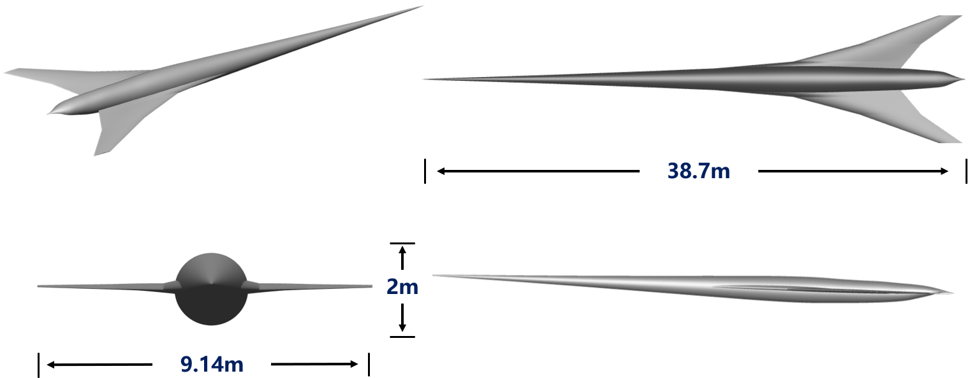 | 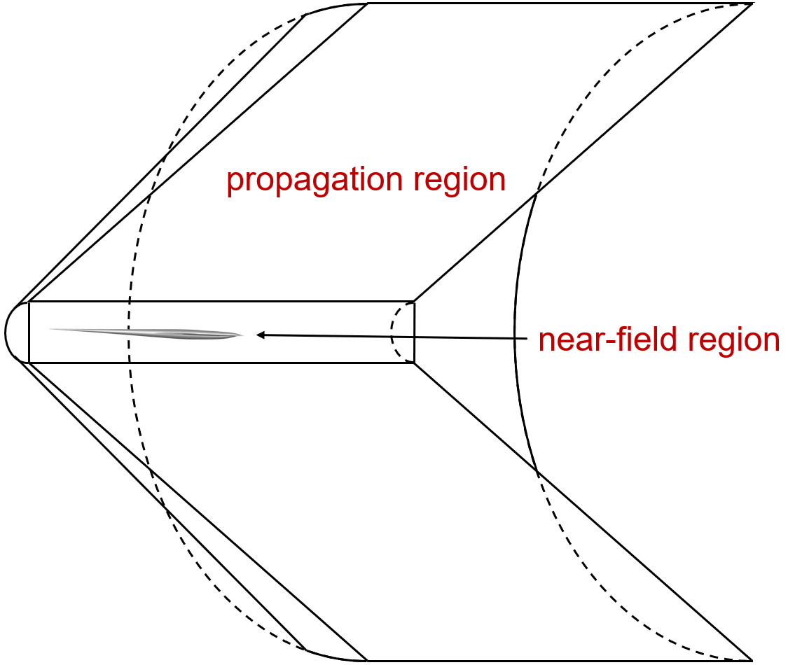
(a) sketch of JWB | (b) grid topology
Figure 2 - Demonstration of geometry and mesh of JWB

Calculation outcomes are compared with data contributed by workshop participants (Figure 3). The near-field pressure waveform achieves favorable consistency with reference results. Discrepancies observed in rear-body waveform primarily originate from intricate local flow features, which induce noticeable deviations among different research outputs. Even so, the overall variation tendency of obtained results aligns well with published datasets. Aerodynamic force predictions also show satisfactory agreement with official benchmark values. The validation confirms the reliability of the adopted CFD method, which can be applied to further detailed flow and wave characteristic analysis.

Table 1 - Information on partial participants in SBPW-2 JWB case
 | Submitter | Mesh Type | Solver | Equations | Mesh Quantity
P1 | Aftosmis | Cartesian | Cart3D | Euler | 8865000
P2 | Magee | Unstructured | FUN3D | Euler | 11335260
P3 | Clemens | Unstructured | FUN3D-VL | Euler | 11335260
P4 | Housman | Structured | LAVA-HWCNS | RANS | 17960265
P5 | Jensen | Unstructured | LAVA | Euler | 3953277

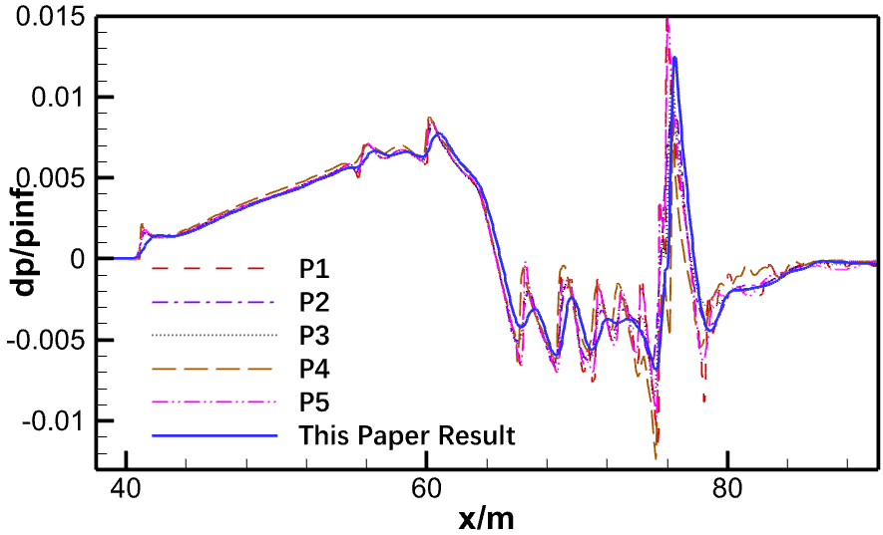 | 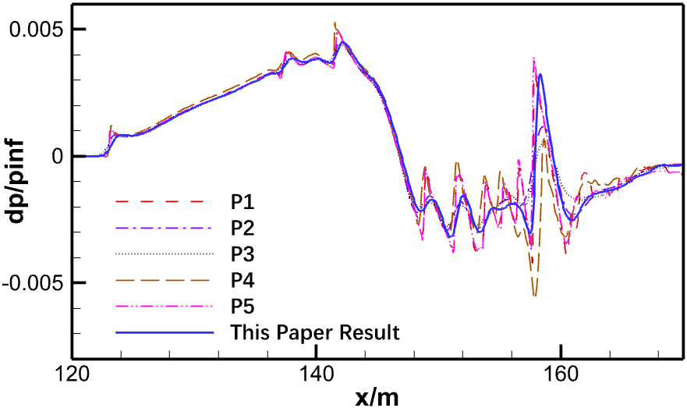
(a) R/L = 0.85 | (b) R/L = 2.55
Figure 3 - Comparison of near-field waveforms of JWB

Sonic Boom Prediction
The sonic boom calculation methods applied in this study are divided into two types. The low-fidelity modified Whitham linear theory is utilized for rapid low-boom design. The far-field propagation method based on the Augmented Burgers equation is integrated with the near-field overpressure waveform calculated by CFD, allowing high-fidelity sonic boom analysis covering both near and far fields.
    - Rapid Sonic Boom Prediction
The JWB model is adopted to validate the rapid sonic boom prediction method derived from modified Whitham linear theory. The corresponding F-function is calculated from equivalent-area distribution to acquire near-field sonic boom characteristics, while lift distribution is solved using the high-order panel method. Comparisons between predicted signatures and CFD outcomes are presented in Figure 4. Results from the rapid method follow basically identical variation trends with high-fidelity calculations, and the attained accuracy satisfies design demands focused on forebody low-boom optimization.

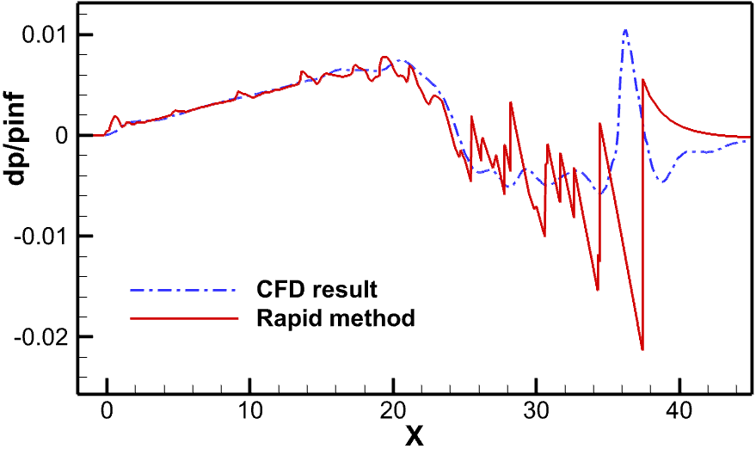 | 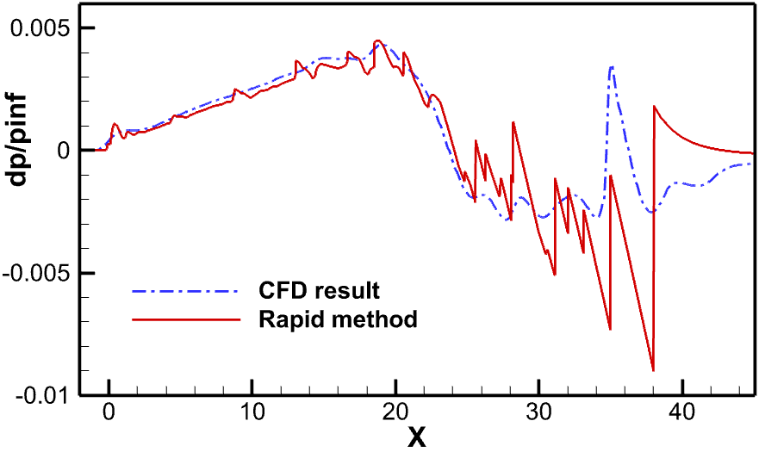
(a) R/L = 0.85 | (b) R/L = 2.55
Figure 4 - Comparison between results of rapid sonic boom prediction method and CFD

    - Far-Field Sonic Boom Propagation
The far-field sonic boom propagation method based on the augmented Burgers equation is employed in this paper. Fluid governing equations are converted into acoustic formulations via equation transformation. With third-order infinitesimal terms neglected and geometric acoustic diffusion together with atmospheric influences taken into consideration, a one-dimensional propagation equation is derived, as expressed below.

(1)
where $p^{'}$ stands for sound pressure and $s$ refers to acoustic ray coordinate. The term $t^{'}=t-\int{ds/c_{0}}$ denotes the delay time of sonic boom waveform, with $c_{0}$ representing ambient speed of sound. Terms on the right side of the equation correspond to diverse atmospheric impacts on sonic boom propagation, covering geometric acoustics, atmospheric stratification, thermoviscous absorption and molecular relaxation. Wave characteristics of sound are neglected in acoustic analysis, and sound propagation is assumed to follow acoustic rays. The equation is therefore solved along sonic boom propagation trajectories. The self-developed sonic boom prediction tool bBoom^{[24]}, is applied in this study, whose reliability has been validated against abundant experimental measurements.
Near-field waveforms acquired via CFD are utilized to validate the far-field propagation approach. Predicted far-field waveform characteristics show good consistency with SBPW data, as displayed in Figure 5, which verifies the high computational precision of the proposed method.

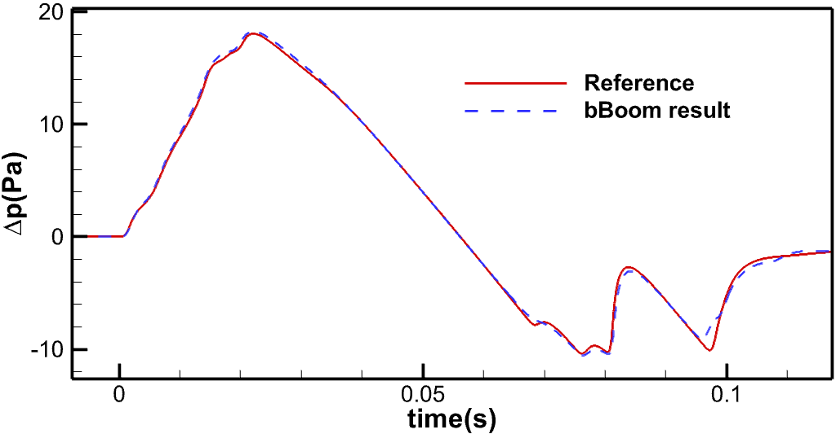
Figure 5 - Comparison of far-field signature of JWB with reference result

Baseline SBWB Configuration

Parametric Method and Baseline Configuration Generation
The TAW fuselage diameter is constrained by cabin size, and its sectional area grows quadratically with the number of seats per row. For large SSTs, this leads to a substantial increase in fuselage volume and raises the difficulty of sonic boom design. In comparison, the BWB adopts a non-circular fuselage that better fits the cabin, providing a more compact volume distribution and lower volume penalty at the same seating capacity (Figure 6). However, the high integration of the cabin and wing makes the traditional split design framework inapplicable, thereby requiring a full-aircraft parametric method dedicated to the SBWB configuration.

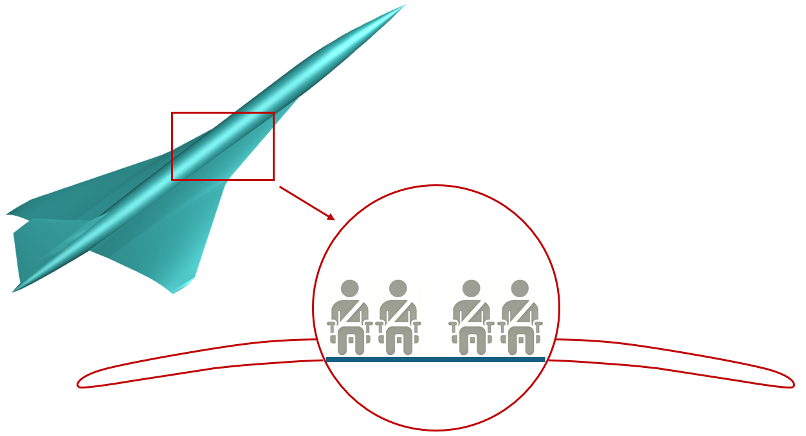 | 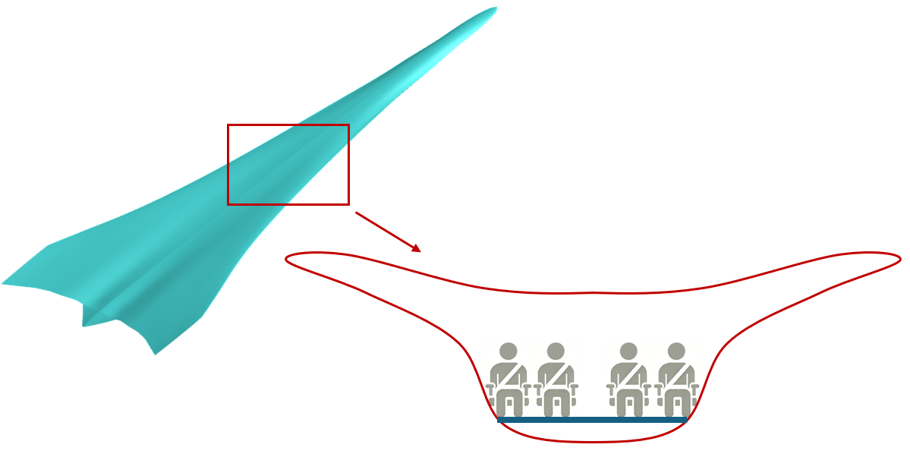
(a) TAW configuration | (b) BWB configuration
Figure 6 - Comparison between TAW and BWB

In view of this issue, a full-aircraft CST parametric method (Figure 7) is adopted in this study to guarantee the global geometric continuity and smoothness of the configuration during optimization. In this approach, the SBWB geometry is defined by a set of closed sectional curves, where all sections are parameterized using CST functions of identical order. Third-order NURBS interpolation is employed between adjacent sections to construct aerodynamic surfaces and maintain second-order geometric continuity. Additional design parameters cover the streamwise coordinates of leading/trailing edges as well as the vertical offset of each section. Low-boom design implemented within this unified parametric framework avoids repeated FFD box reconstruction and re-parameterization induced by geometric deformation.
During surface generation, CST parameters are constructed based on Bernstein polynomials with infinite-order differentiability everywhere, which preserves the G2 continuity of streamwise grids for all sections. Similarly, cubic NURBS surfaces can theoretically achieve inherent G2 continuity without extra modification. Accordingly, the present parametric method enables full-aircraft surfaces to maintain continuous G2 characteristics throughout the configuration. On this basis, additional constraints are imposed on the spanwise surface geometry to avoid structurally infeasible shapes in engineering practice. Total curvature variation and second-derivative inflection criteria are adopted in this work as practical engineering constraints.

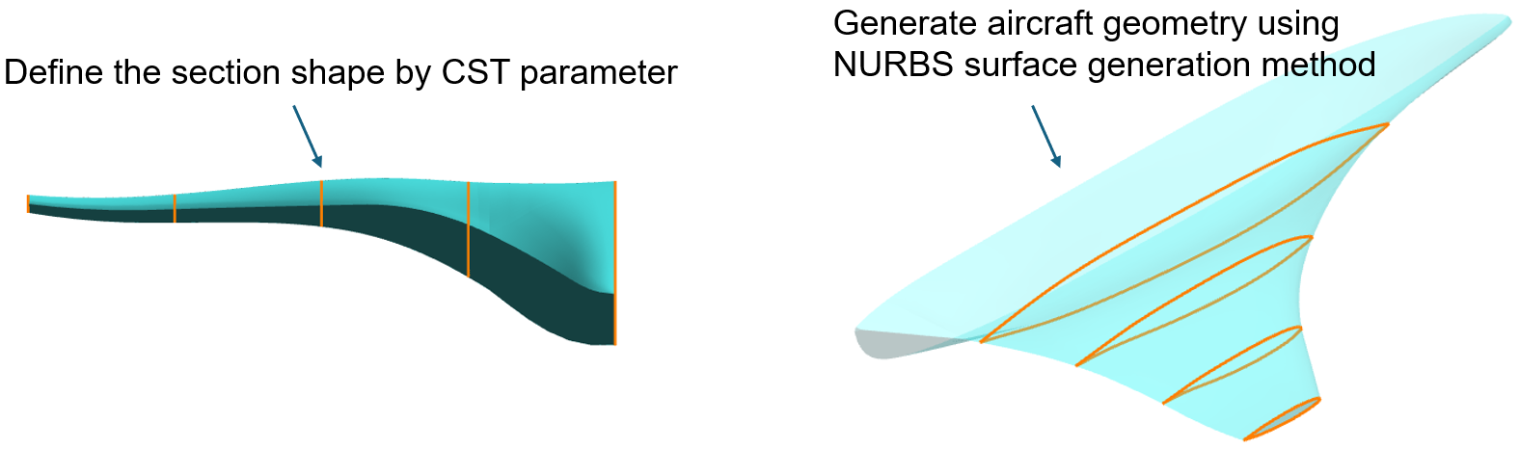
Figure 7 - SBWB parametric method based on CST parameters

The cabin envelope is established as the primary geometric constraint for SBWB parametric modeling. A 160-seat layout with 40 rows and four seats per row is configured, and major cabin dimensions are specified to meet passenger comfort demands. Due to the limited internal space of supersonic transport, overhead luggage racks are eliminated to prevent spatial crowding. Baggage storage is arranged in the tapered section of the rear fuselage instead.
The longitudinal symmetry-plane contour is generated according to the cabin boundary dimensions. The overall aircraft length is reasonably configured with a reserved height margin to compensate for geometric shrinkage in the spanwise direction. Key control points at the front, rear, upper and lower boundaries of the cabin symmetry plane are selected, and a CST curve is fitted to construct the baseline profile. During the baseline configuration design, offsets are applied to the nose and tail to increase the effective aircraft length, providing a good geometric foundation for subsequent low-boom optimization.

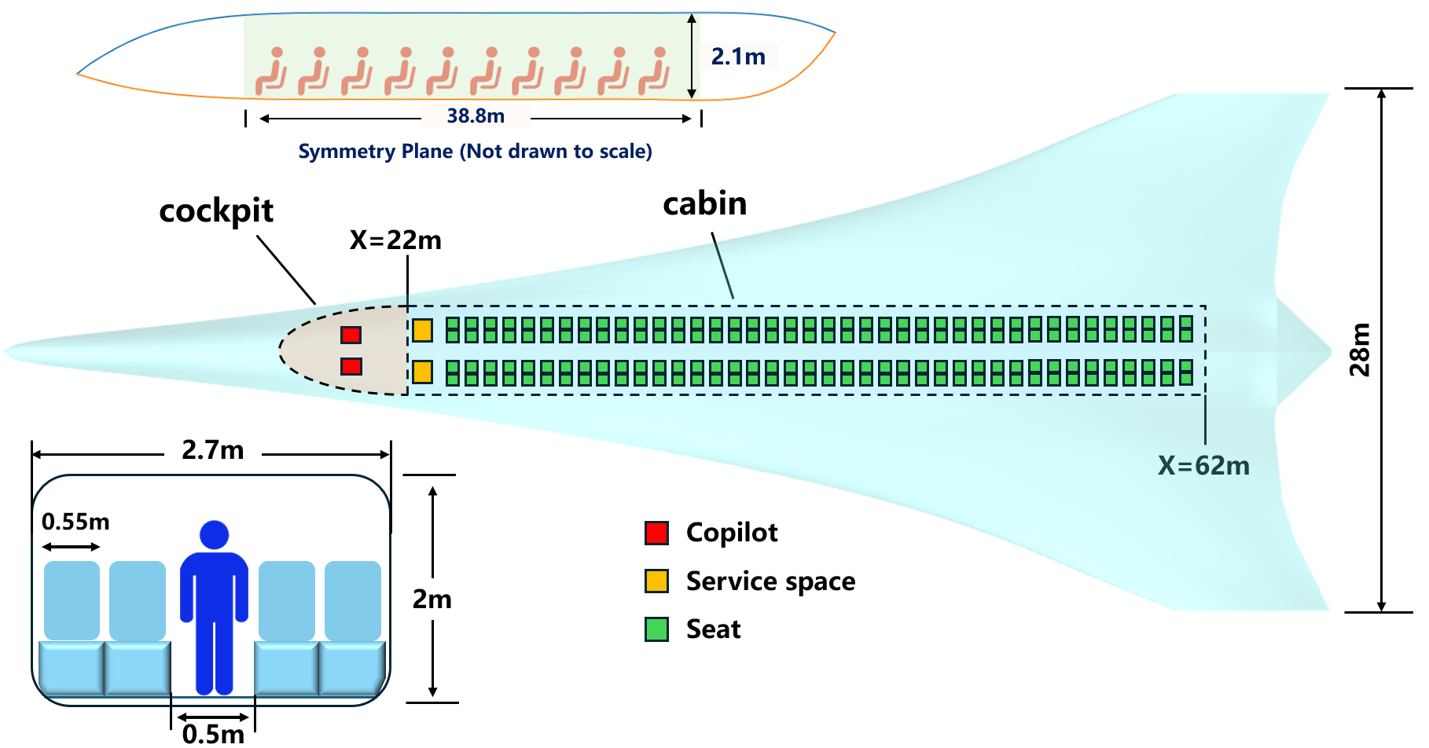
Figure 8 - Demonstration of cabin Interior space

A 3%-thickness thin airfoil is applied uniformly to the outboard wing sections away from the cabin. The sectional profiles of the middle fuselage are acquired by interpolating the airfoil parameters between the outboard wing and the symmetry plane, and the initial aerodynamic configuration is thus constructed.
Considering flight efficiency and sonic boom characteristics, the cruise condition adopted in this study is set as a cruise altitude of 18 km and a cruise Mach number of 1.8, and the total weight of SBWB is 150t. To match the lift of the shape with the design weight, the leading-edge curve is further parameterized by a cubic polynomial, and the rapid lift-increasing optimization is carried out on the initial shape, thereby obtaining the baseline configuration of this paper (Figure 9).

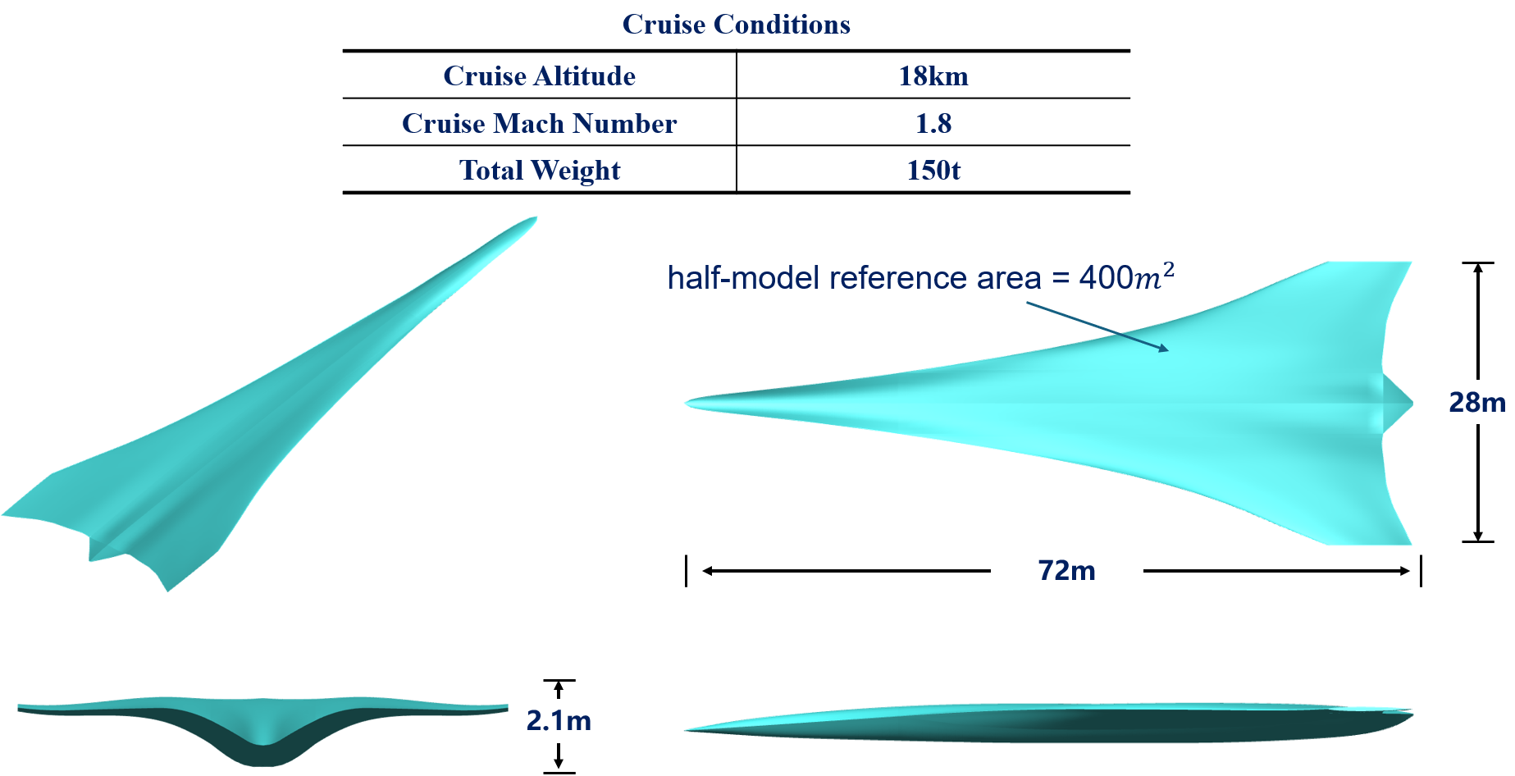
Figure 9 – Sketch of baseline configuration

Aerodynamic Analysis of the Baseline Configuration
Aerodynamic and sonic boom characteristics of the baseline configuration are analyzed in this paper. As the panel method serves as the lift assessment tool in primary rapid optimization, the cruise angle of attack is firstly evaluated via high-fidelity calculation with relatively coarse aerodynamic mesh. The sonic boom mesh is then generated according to the acquired cruise angle of attack.
The cruise angle of attack obtained from aerodynamic evaluation is 4.1 degrees. Although the total weight set in this paper is larger than that of most existing supersonic transport concepts, the cruise angle of attack is only 4.1 degrees, which improves passenger comfort to a certain extent. The cruise lift-to-drag ratio is 11.2. The lift coefficient is 0.107. The pressure drags and viscous drag account for 62.2% and 37.8% respectively, indicating that most of the drag is generated by volume, which is consistent with the basic assumption of large-sized SBWB. It can be seen from the pressure distribution (Figure 10) that the low-pressure region of SBWB appears earlier than that of the TAW configuration. The TAW configuration is usually designed with a very slender nose, which generates lift almost from the position close to half of the fuselage length. However, the non-lifting region of SBWB is only a part of the nose. The early generation of lift may provide a new direction for the forebody waveform design. In JSGD inverse design for TAW configurations, nose shock intensity generally needs to be enhanced. Stronger bow shock helps avoid shock coalescence. Earlier lift generation of SBWB enables part of the equivalent area at the nose to be contributed by aerodynamic lift, thereby reducing drag produced at the nose.

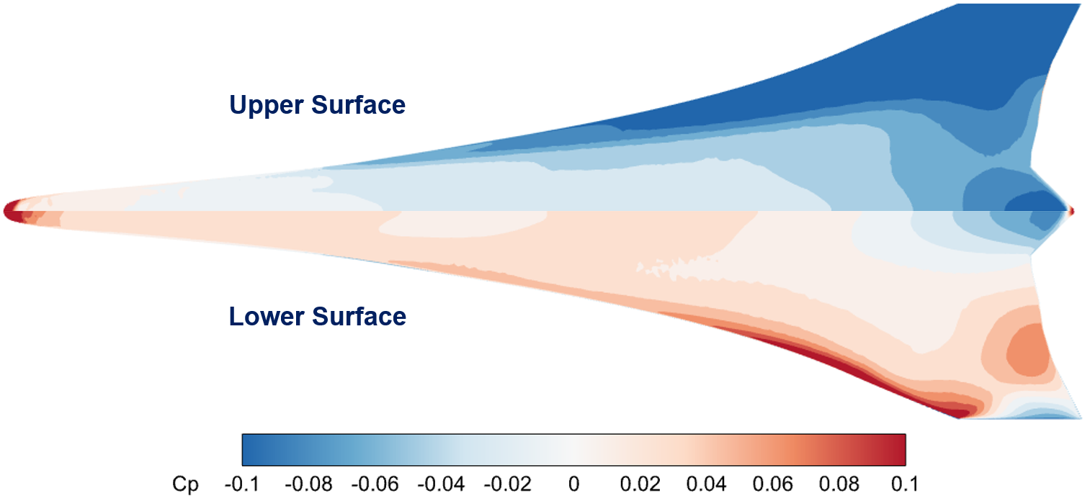
Figure 10 – Pressure distribution on upper and lower surfaces

Figure 11 illustrates the near-field symmetry-plane overpressure distribution derived from sonic boom numerical analysis. The forebody pressure waveform of the proposed SBWB configuration exhibits a generally similar variation trend to that of the conventional TAW configuration. Nevertheless, constrained by the substantially extended cabin length of the large-capacity SBWB layout, the tapered transitional section of the rear fuselage is severely compressed on a longitudinal scale. The abrupt volumetric contraction of the aft fuselage induces intense local over-expansion flow, which constitutes a prominent unfavorable factor for low-boom design. In this regard, compared with conventional TAW supersonic schemes, the SBWB configuration faces more prominent afterbody waveform defects, indicating that subsequent low-boom optimization for the SBWB should focus primarily on the suppression and regulation of adverse afterbody wave characteristics.
Furthermore, the sonic boom signal extracted at a downstream distance of three times the fuselage length (R/L=3) beneath the aircraft is analyzed in detail. For comparative reference, the near-field waveform of conventionally designed configurations without low-boom optimization typically contains two intense shock waves, which are separately induced by the volumetric discontinuity at the nose and the lift discontinuity at wing leading edge. In contrast, the fore-body waveform of the baseline SBWB in this study exhibits a flat-top waveform. This waveform characteristic is presumably attributed to its extended lift distribution range and the axial coupling effect between volumetric variation and lift variation along the fuselage. In the traditional low-boom design of TAW configurations, the classic split design concept assumes that the modification of fuselage volume distribution exerts negligible influence on aircraft lift performance. However, the analytical results indicate that this conventional assumption is no longer applicable to the SBWB configuration, which further demonstrates the essential necessity of implementing integrated aerodynamic and low-boom design for SBWB.
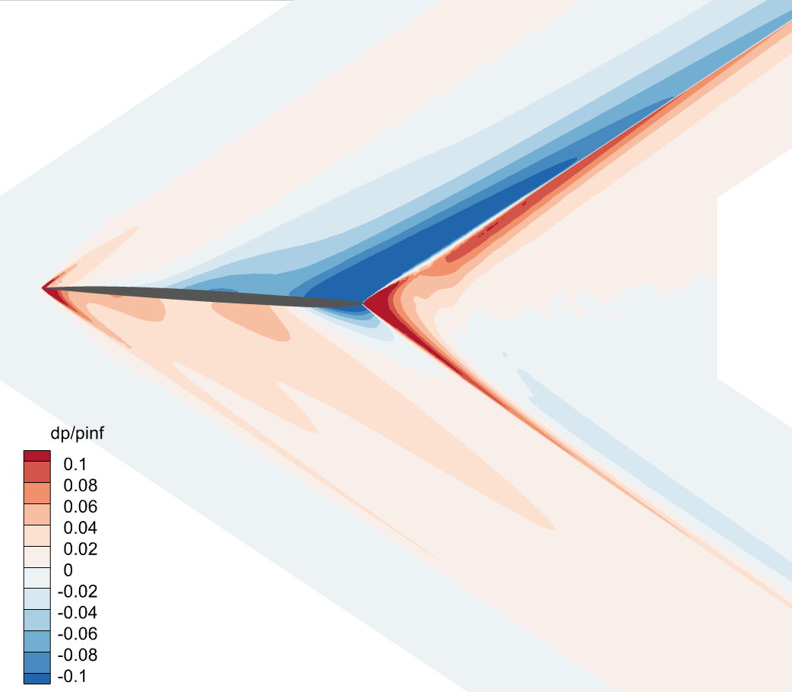 | 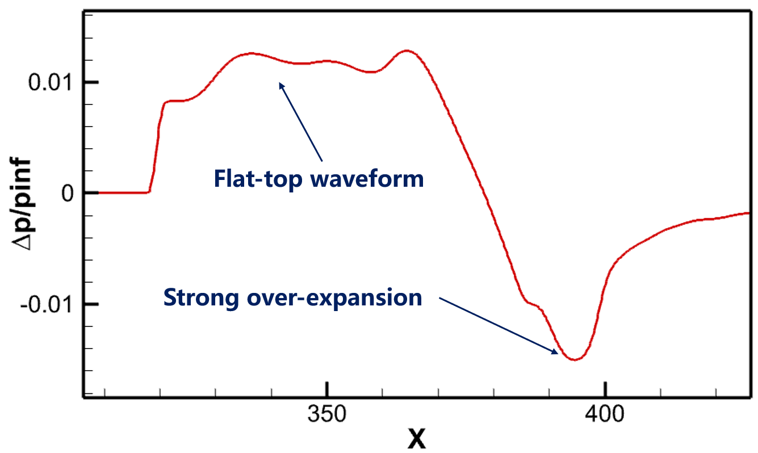
(a) Overpressure distribution | (b) $Δp/p_{∞}$at R/L = 3
Figure 11 – Overpressure distribution and sonic boom signature at R/L = 3

Far-field propagation calculation based on near-field sonic boom waveforms reveals that the ground sonic boom intensity directly beneath the aircraft reaches 105.67 PLdB, a magnitude comparable to that of the Concorde airliner. Observations on the far-field waveform show that although its overall trend is close to a typical N-wave, the leading shock waves are not fully merged and present indistinct multiple shock wave characteristics. This phenomenon demonstrates that the overall sonic boom intensity of the SBWB configuration is mainly determined by shock wave merging and the large amplitude induced by high lift. Accordingly, the classic JSGD theory will be separately applied to conduct low-boom design on the SBWB model, to explore the effective potential of sonic boom suppression for this configuration.

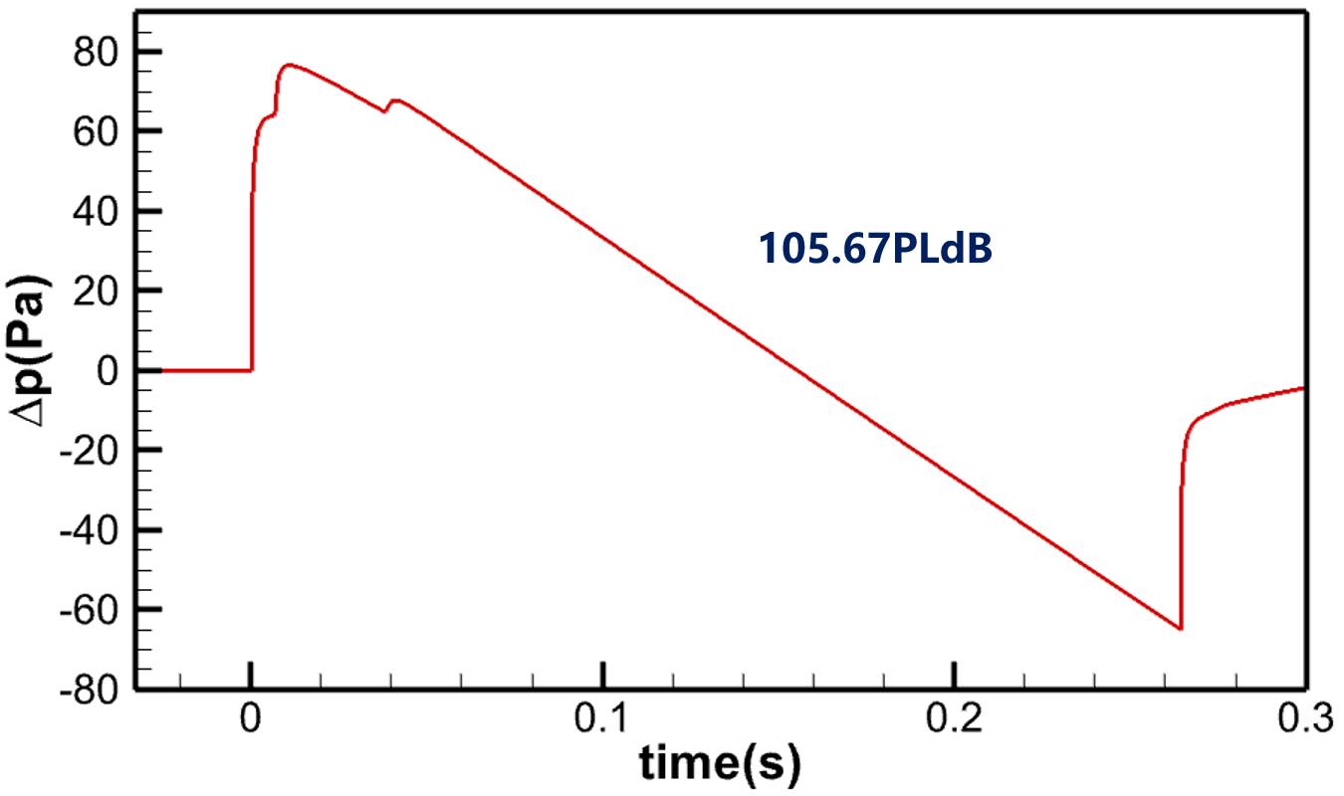 | 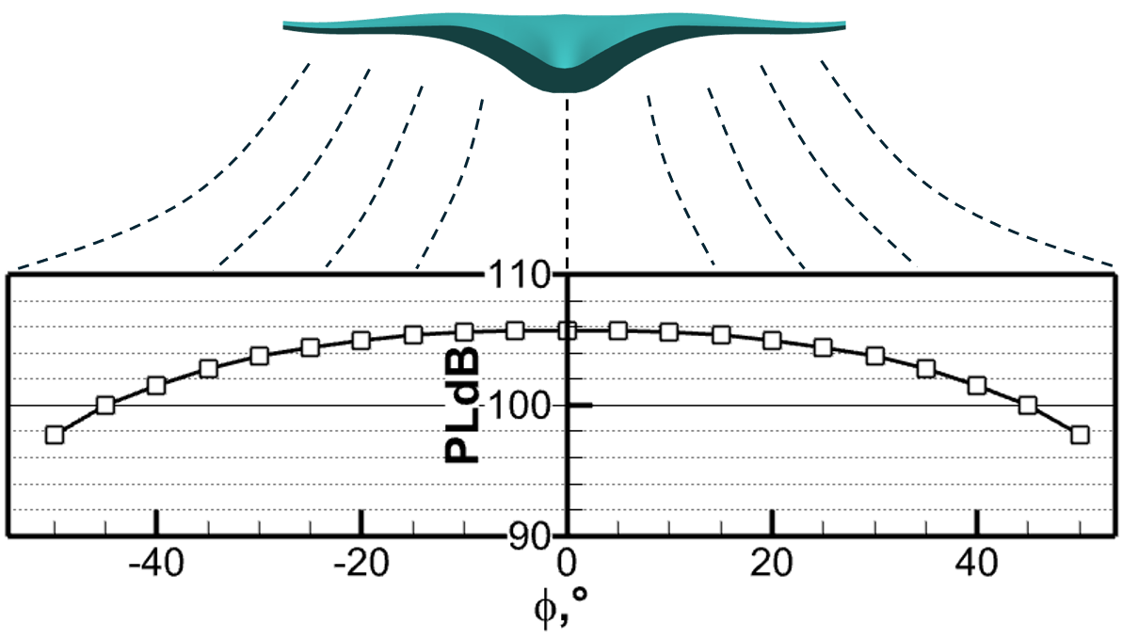
(a) Ground waveforms | (b) carpet PLdB of SBWB
Figure 12 – Ground waveforms and carpet PLdB distribution

Result and Analysis

Fore Body Waveform Analysis and Inverse Design
Sonic-boom minimization theory, also referred to as shaped sonic-boom theory, was established by Jones^{[9]}, George^{[10]} and Seebass^{[11]}, and Darden^{[12]}. The core principle of the JSGD inverse design method is summarized as follows. First, based on the sonic-boom minimization theory and key flight parameters including the aircraft’s cruise altitude, fuselage length, and cruise weight, the low-boom optimized F-function with excellent sonic boom suppression performance is derived. Second, the target equivalent area distribution is calculated from the obtained F-function. Finally, aerodynamic configuration optimization is implemented to match the practical equivalent area distribution with the target distribution, thereby realizing effective sonic boom attenuation.
Although the fuselage length set in the baseline configuration generation stage is 72 meters, its effective length cut by the Mach surface should be used when generating the JSGD target due to the cruise angle of attack. This paper uses 68 meters as the effective length to generate the JSGD equivalent-area distribution target. Figure 13 shows the target F-function and comparison between the equivalent-area of baseline configuration and the target equivalent-area distribution adopted in this paper.

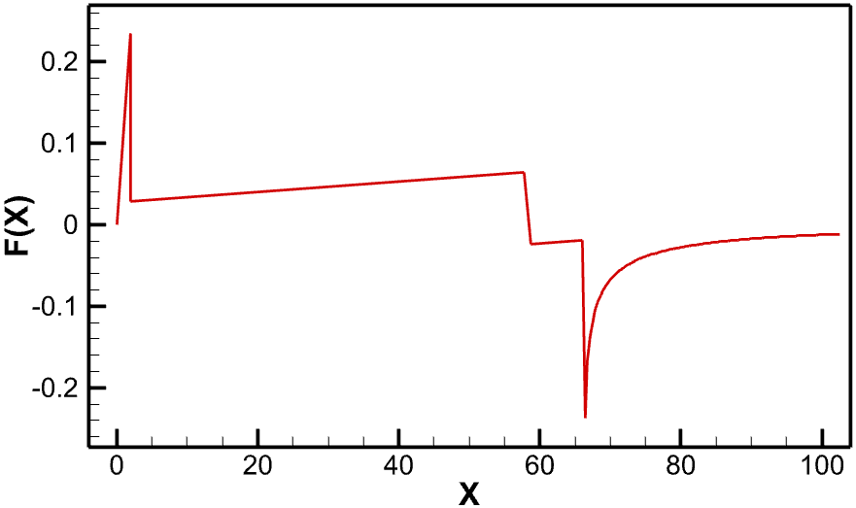 | 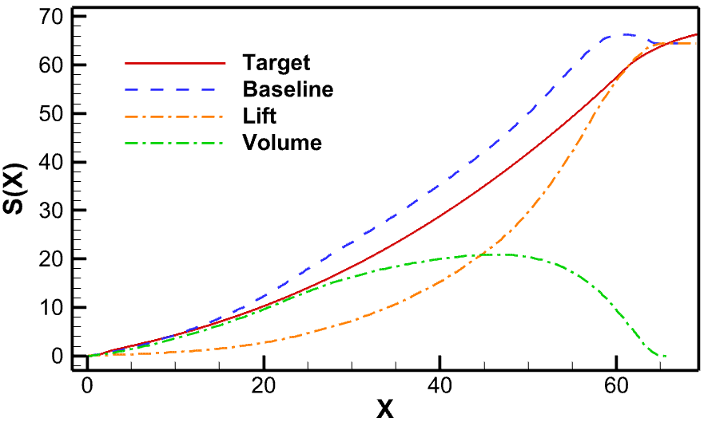
(a) Objective F-function | (b) Equivalent area distribution
Figure 13 - Objective F-function and equivalent area distribution

It can be observed from the equivalent-area distribution that the large-volume cabin dominates the overall equivalent-area variation. The 160-seat cabin structure is analyzed and modeled independently, with conical profiles adopted to substitute the nose and tail sections to keep the start and end positions of equivalent-area distribution consistent with those of the full aircraft configuration. Considering practical shapes must maintain convex characteristics, this profile serves as the lower limit of equivalent area under the designated cabin volume. The geometric boundary of minimum equivalent area is then enclosed by circular fuselage sections, and the relevant sectional area distribution is compared with that of the baseline SBWB configuration as illustrated in Figure 14. The comparison shows that the equivalent area of circular cabin sections is obviously larger than that of the SBWB structure. It demonstrates that circular fuselage forms impose tighter constraints on equivalent-area adjustment in large-sized SST design, which increases design difficulty and may even prevent the target distribution from being achieved.

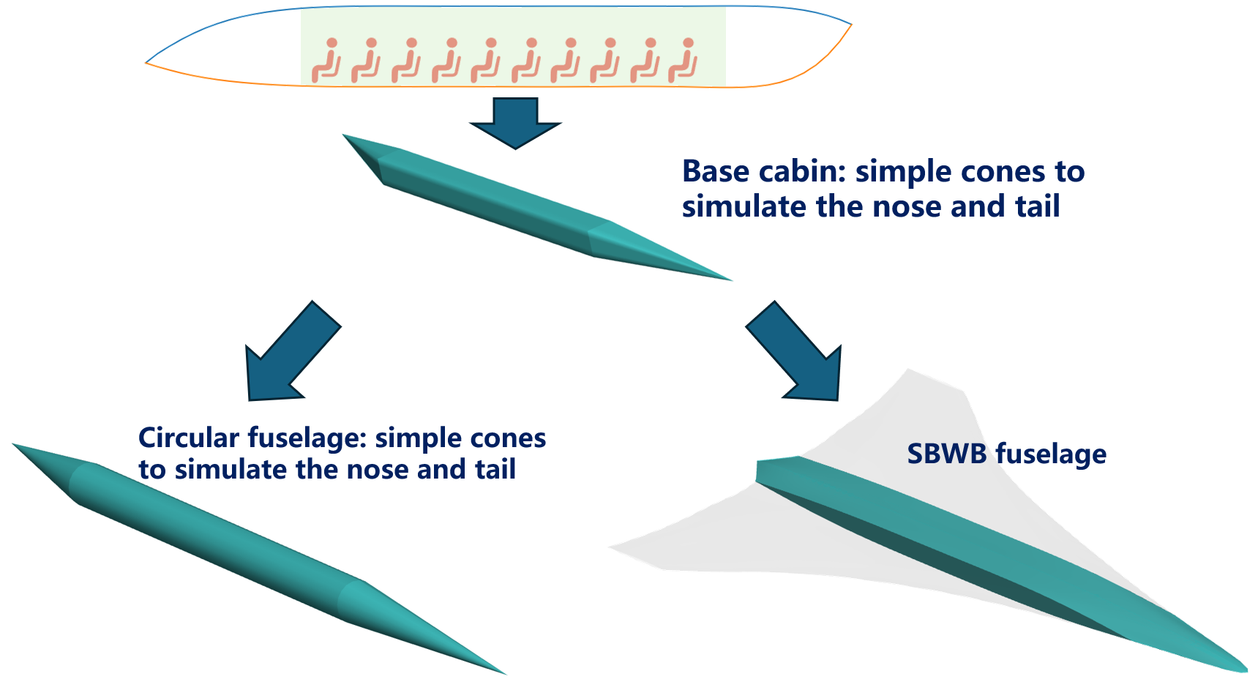 | 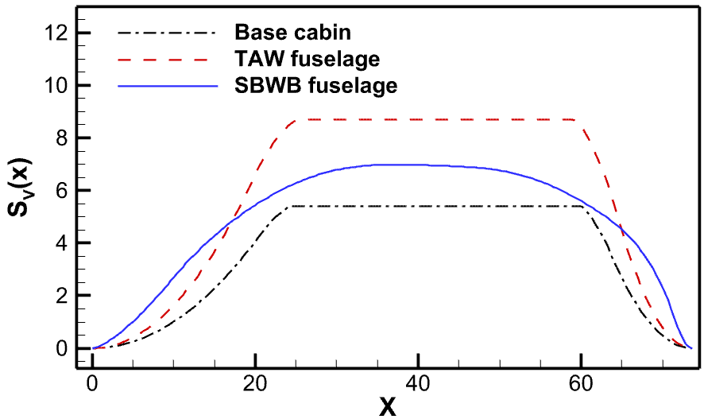
(a) generate different fuselage base cabin | (b) equivalent-area distribution
Figure 14 – Fuselage-area distribution of TAW and SBWB

This paper carries out JSGD inverse design based on the full-aircraft parameterization method introduced in 3.1. Ten sections are adopted with 5-order CST parameters. The span-wise stations of each section are fixed and not involved in the design, with a total of 160 design variables.
To avoid slow convergence in high-dimensional optimization, the optimization is divided into two stages. The first stage is planform optimization, in which the 12 CST parameters of each section are fixed, and the leading and trailing edge positions, z-direction offsets, and relative trailing edge offsets of the sections are optimized. The leading and trailing edge positions and z-direction offset of the symmetry plane remain unchanged, with a total of 37 design variables. The optimization objective is the integral of the difference between the equivalent-area distribution and the target distribution. This part has little influence on the total volume of the aircraft, and its main purpose is to find the lift distribution that best matches the target distribution.
This study conducts JSGD inverse design using the full-aircraft parameterization method presented in Section 3.1. Ten sections are defined with fifth-order CST parameters. The spanwise stations of all sections are kept fixed and excluded from design variables, yielding a total of 160 design variables in total.
To address slow convergence in high-dimensional optimization, the design is divided into two stages.
The first stage performs planform optimization with CST parameters of each section fixed. It optimizes leading/trailing edge positions, z-direction offsets and relative trailing edge offsets of individual sections, while keeping parameters at the symmetry plane unchanged. With 37 design variables, this stage minimizes the integral of deviations between actual and target equivalent-area distributions. It barely changes the aircraft volume and mainly aims to obtain an optimal lift distribution.
The second stage refines section shapes with the planform fixed, involving 120 design variables. A block-based strategy is adopted for this high-dimensional problem. A random subset of variables is selected to update the target volume equivalent-area, which requires no flow computation and incurs little cost. The differential evolution algorithm is used for sub-optimization. Results are accepted if the equivalent-area is improved; otherwise, they are discarded and new variables are sampled. In this work, the 120 variables are randomly split into 10 groups for sub-optimization. After regrouping and repeating the process three times, 30 iterations and lift evaluations are completed, with 20 accepted and 10 rejected.

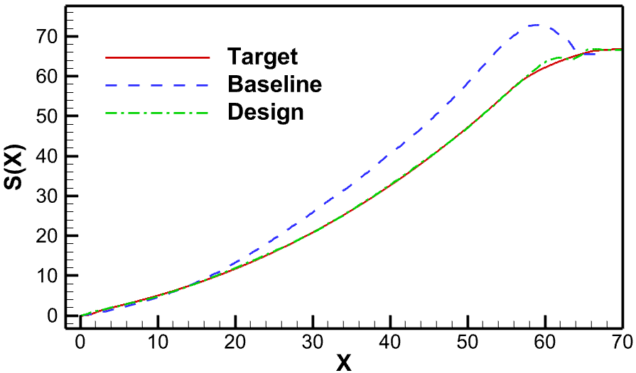 | 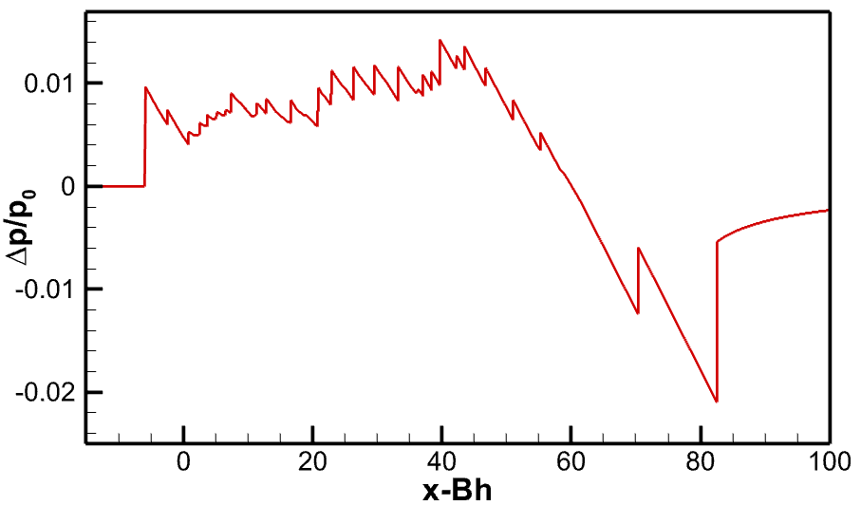
(a) Optimized equivalent-area distribution | (b) Signature calculated by rapid method
Figure 15 - Optimized equivalent area distribution and near-field overpressure signature

The optimized configuration is evaluated for aerodynamic and sonic boom characteristics with high fidelity CFD method. Due to certain errors in the lift analysis using the panel method, the cruise angle of attack of the inverse‑designed configuration under high‑fidelity analysis is somewhat different from the panel method result, so the calculated sonic boom signature does not fully match the JSGD target waveform. We observe that the optimized rear-body waveform generates a relatively strong shock wave. This is mainly attributed to poor equivalent-area matching at the rear-body section. The rapid contraction of the empennage intensifies expansion waves, which to some extent inhibits the forward merging of shock waves formed at the fuselage trailing edge. It is worth noting that due to the use of relatively low‑order CST parameters for parameterization, the shape smoothness is high, so the waveform also shows high smoothness without small discontinuities commonly seen in the design results of conventional configurations. However, in classical sonic boom theory, these small discontinuities may help prevent compression wave merging and thus reduce sonic boom. To generate such features in the waveform, it may be necessary to further increase the order of CST and adopt effective methods to filter the strange shapes caused by the increase of CST order.

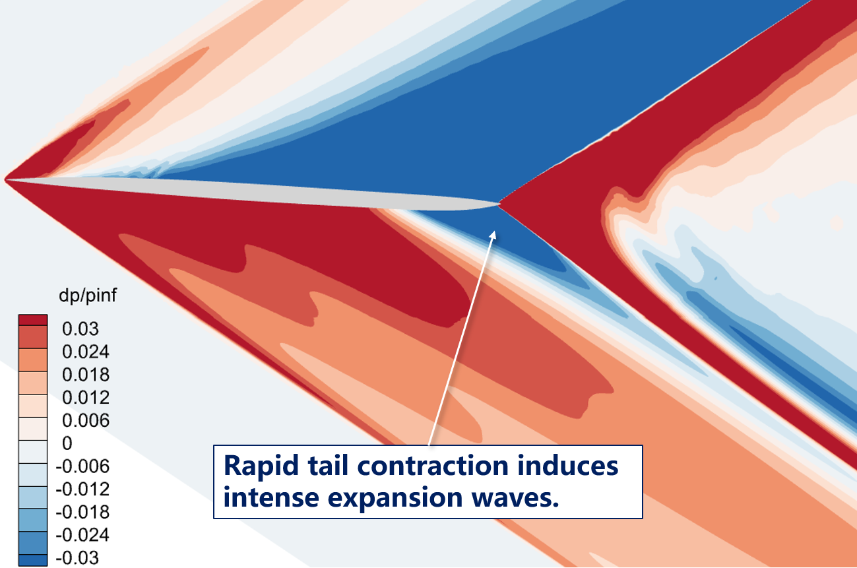 | 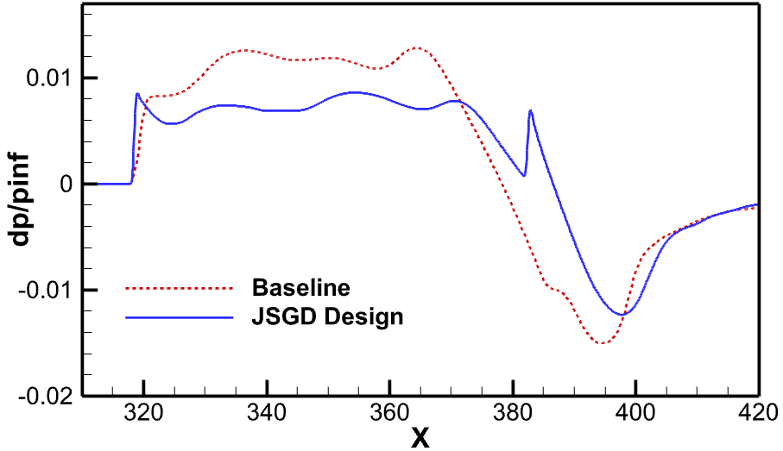
(a) Overpressure distribution | (b) Waveform at R/L = 3
Figure 16 – Optimized overpressure distribution and waveforms at R/L = 3

The far-field propagation calculation is performed on the sonic boom signal at three times the fuselage length to obtain the ground waveform and the PLdB distribution at circumferential angles. The sonic boom intensity directly below is reduced to 99.21 PLdB (Figure 17), which is 6.46 PLdB lower than that of the baseline configuration. It is worth noting that the sonic boom reduction effect is even better at positions with small azimuth angles than directly beneath the aircraft. This is because the overall volume is reduced to a certain extent during optimization, and the volume contribution from lateral positions gradually becomes dominant. Consequently, the boom mitigation performance is less constrained by lift requirements.

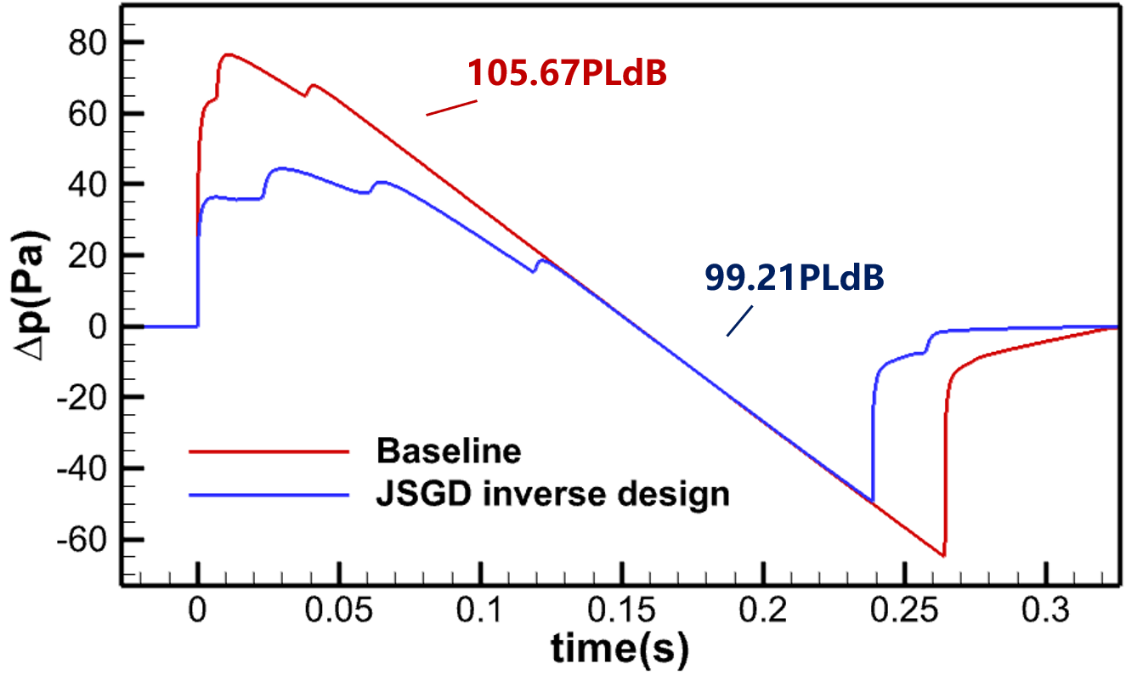 | 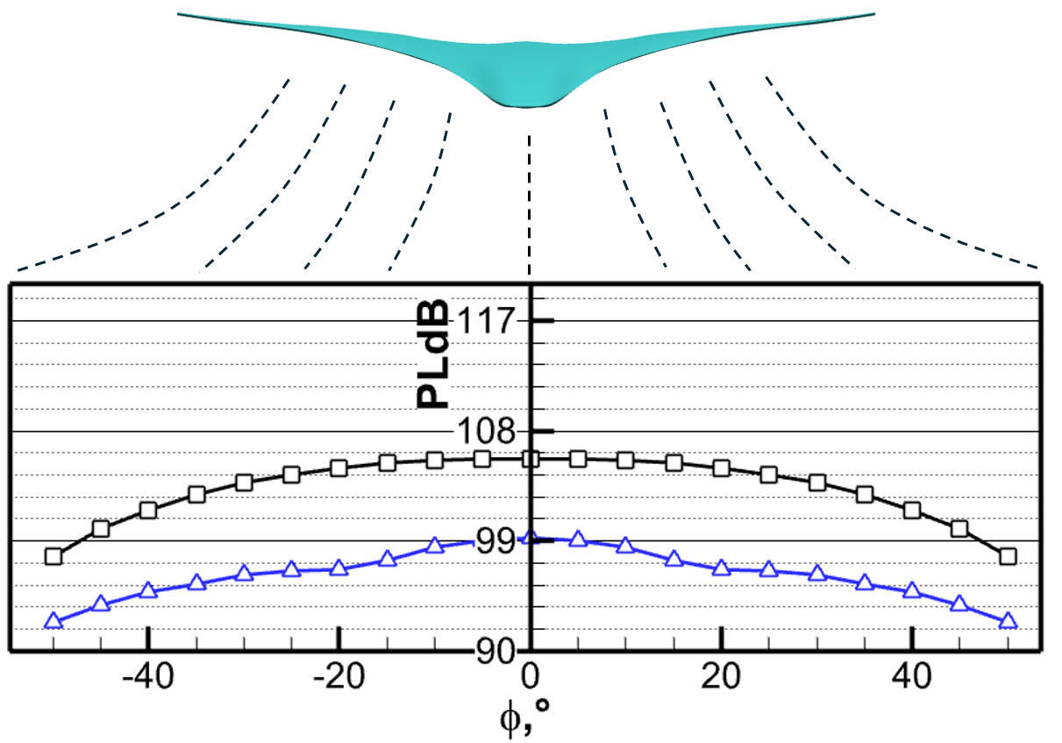
(a) Ground waveforms | (b) carpet PLdB
Figure 17 – Optimized ground waveforms and carpet PLdB of SBWB

In this section, the JSGD inverse design method is adopted to carry out low-boom design for the SBWB configuration, and waveforms like theoretical waveform of minimum sonic boom. The results prove that classic low-boom design methods are still well applicable to the SBWB configuration.

Rear Body Waveform Analysis
The above low-boom design is fully implemented based on a tailless clean configuration. Although such tailless configuration have become a major research direction, especially in the design of hypersonic aircraft and supersonic fighters, they are generally regarded as unsuitable for civil airliners due to difficult control characteristics. Hence, it is necessary to add additional components to the basic configuration to take control performance into account. In addition, the analysis on sonic boom characteristics of the clean configuration reveals extremely strong expansion waves at the rear body, which cannot be effectively improved in subsequent low-boom design processes. In the low-boom design of TAW configurations, control surfaces are widely adopted as an effective way to adjust rear-body waveform. It is worth exploring whether this method can also be applied to the low-boom design of SBWB. Therefore, this paper selects winglets and V-tails, which are commonly used in BWB design, to study their influences on sonic boom signatures.
The dimensions of winglets and V-tails are calculated by empirical formulas. The planform sizes and installation positions of the two components are shown in Figure 18. Symmetric thin airfoils are adopted for V-tails to balance control efficiency and aerodynamic drag reduction, while winglets directly use the same airfoil as the wing tip.

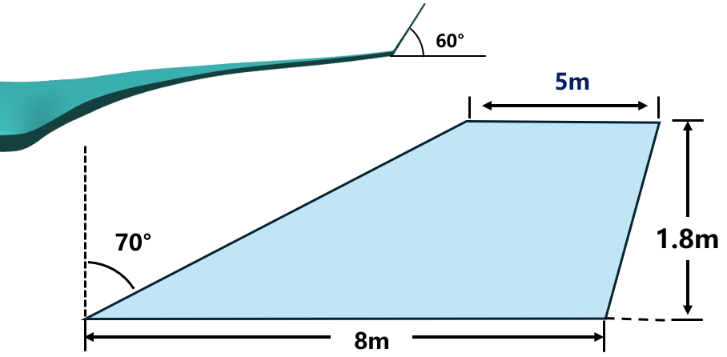 | 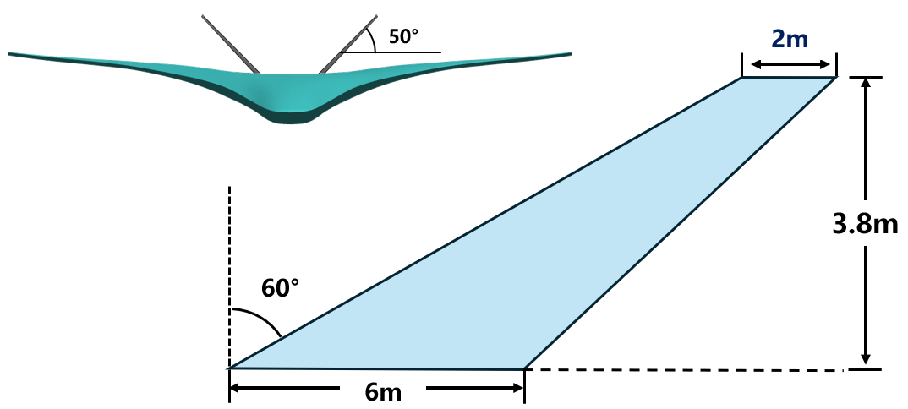
(a) dimensions of winglets | (b) dimensions of V-tails
Figure 18 – Geometry of the winglet and V-tail

Winglets and V-tails are separately installed on the optimized configuration for high-fidelity analysis. To ensure the influences of additional components act on the identical determined waveform obtained after JSGD inverse design, all sonic boom analyses are conducted at a fixed angle of attack.
It is observed that installing winglets alone slightly intensifies the shock wave formed at the terminal section of the volumetric distribution and alleviates the over-expansion phenomenon of the rear-body to a certain extent. Previous research has confirmed that wingtip vortices propagate downstream along the Mach cone and interact with the over-expansion flow field behind the rear-body shock. Such mutual interaction further amplifies the magnitude of over-expansion through wave superposition. On the one hand, additional flow disturbances induced by winglets superimpose onto the rear-body waveform, leading to a moderate rise in shock wave amplitude. On the other hand, winglets perform well in restraining intense wingtip flow disturbances and hinder the backward propagation of low-pressure flow over the wing upper surface, which prevents these flow features from interacting with the rear-body over-expansion region. Despite the above improvements, the overall suppression effect on over-expansion still fails to meet the anticipated design targets.
Further comparative analysis on the rear-body waveform of the clean configuration and the winglet-fitted model indicates that the shock wave generated at the fuselage tail is extremely strong. During downstream propagation, the majority of low-pressure disturbances originating from wingtip flow are intercepted by this robust rear-body shock and therefore cannot travel to the symmetry plane to form superimposed flow structures. This result demonstrates that wingtip vortex disturbances only take a small proportion of the factors triggering rear-body over-expansion, even for the original clean configuration. Accordingly, merely suppressing wingtip flow disturbances is insufficient to achieve desirable performance in sonic boom mitigation.

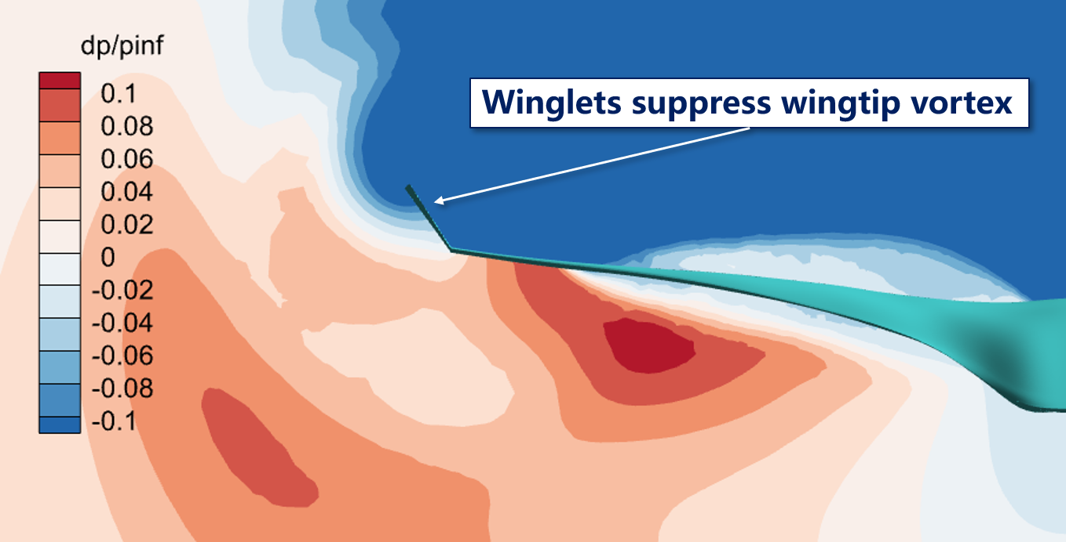 | 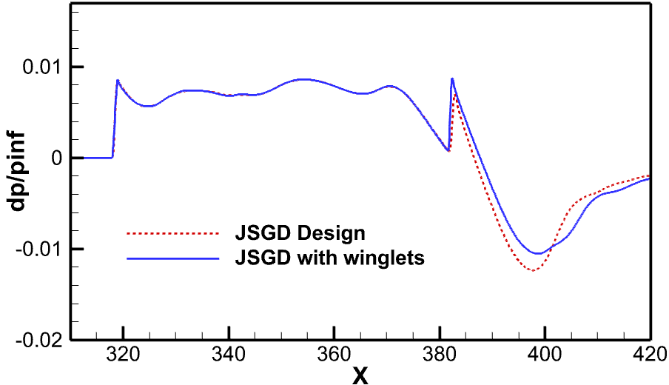
(a) Upper surface overpressure distribution | (b) comparison of waveform
Figure 19 – Influence of winglets on sonic boom characteristics

In contrast, simply equipping the aircraft with V-tails exerts a negligible influence on the waveform. Flow field analysis indicates that the symmetric V-tails with zero incidence angle generate minor flow disturbances, most of which are shielded by the fuselage and fail to affect the sonic boom waveform below, resulting in limited capability for wave system regulation. It is worth noting that V-tails with preset incidence angles are adopted in some existing designs to compensate for lift. As expected, such configurations produce stronger flow disturbances and may impose a more pronounced impact on the waveform.

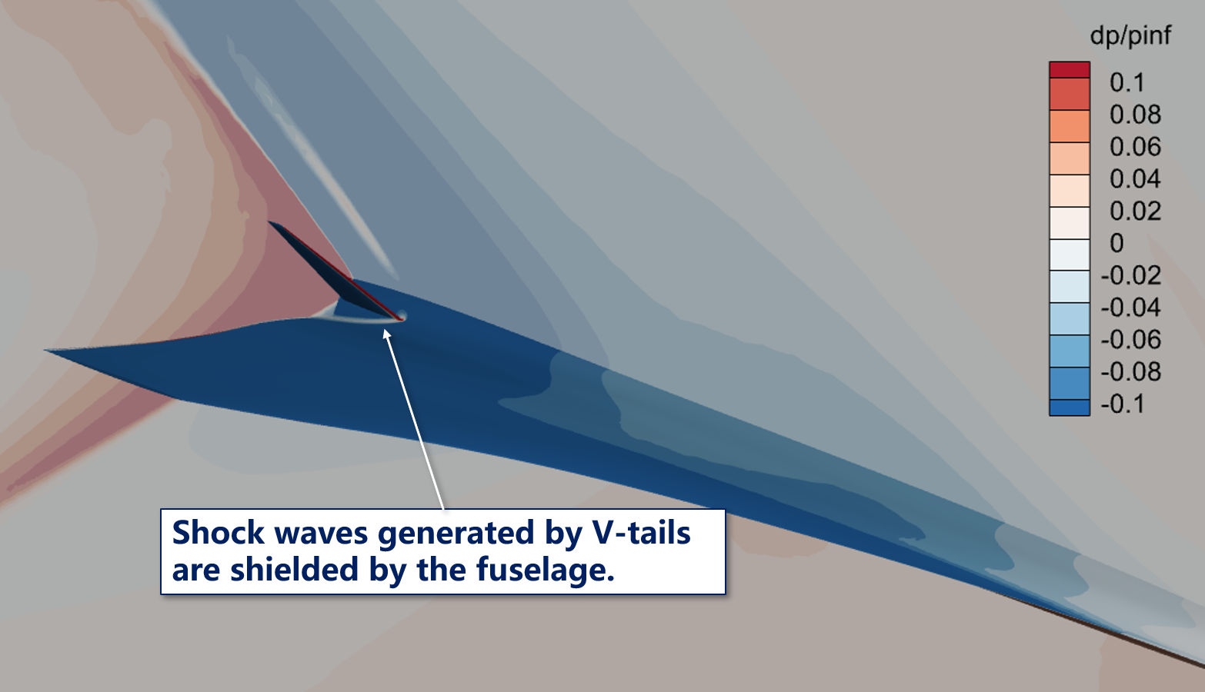 | 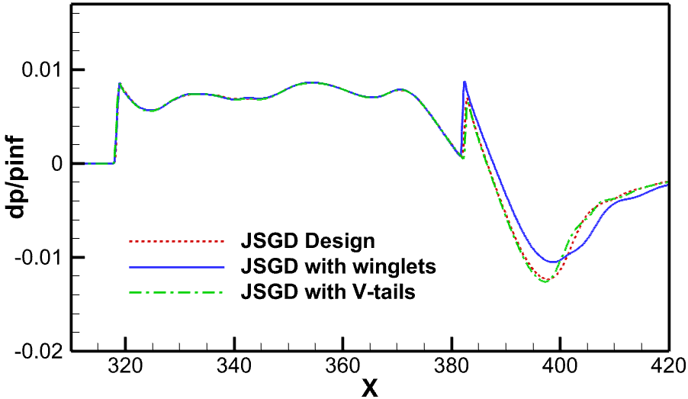
(a) Upper surface overpressure distribution | (b) Comparison of waveform
Figure 20 – Influence of V-tails on sonic boom characteristics

Subsequently, winglets and V-tails are both mounted on the JSGD designed configuration for sonic boom characteristic analysis. According to the near-field waveform results, although V-tails exert negligible influence on the wave system when applied alone, the combined effect of the two components differs from the simple superposition of their individual performances after integrated installation. The rear-body over-expansion intensity generated by the coupling effect of the two components is further slightly weakened, and the shock wave enhancement induced by winglets is also suppressed to a certain extent. This indicates that a mutual interference effect exists between the flow disturbances produced by winglets and V-tails, which favorably improves the near-field wave system structure and achieves a partial weakening of the adverse aerodynamic wave characteristics. Near-field waveform signals at different azimuthal angles are propagated to the ground for far-field sonic boom evaluation. The calculation results demonstrate that the ground sonic boom intensity directly beneath the aircraft is reduced from 99.2 PLdB to 98.7 PLdB after the combined installation of winglets and V-tails, verifying the effective sonic boom suppression capability of the compound aerodynamic configuration.

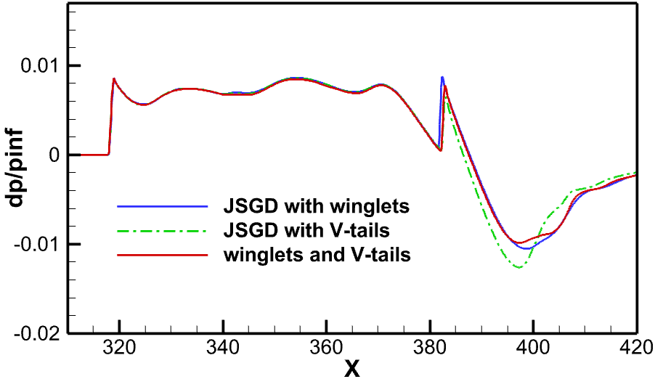 | 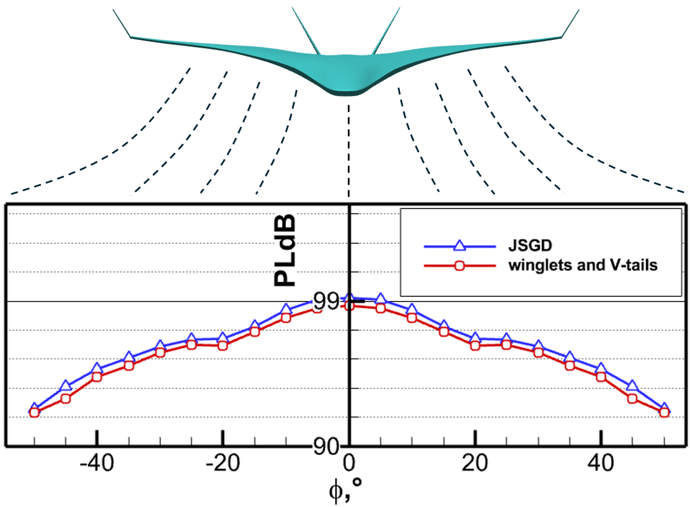
(a) Comparison of waveform | (b) carpet PLdB
Figure 21 - Influences of aerodynamic components on sonic boom characteristics

This section investigates the effects of winglets and V-tails on the sonic boom characteristics of the SBWB configuration. The results show that winglets can effectively mitigate the over-expansion of the rear-body. V-tails deliver limited improvement when used alone, yet they can further enhance regulation performance when combined with winglets. It should be noted that the severe rear-body over-expansion of the present configuration may mask the effects of these components to some extent. Further research is still required to reveal the underlying mechanisms of how aerodynamic components affect the sonic boom characteristics of SBWB layouts.

Conclusion
This paper discusses the aerodynamic feasibility and sonic boom feasibility of a 160-seat large-sized SBWB. It is found that the SBWB configuration features a smaller cruise angle of attack and a wider lift distribution range. And its fuselage fits the cabin structure better, which is conducive to equivalent area distribution matching in low-boom design. Based on the above research results, the classic JSGD inverse design method is adopted in sequence to conduct low-boom design for the SBWB, and the ground sonic boom intensity is reduced from 105.67PLdB to 100.53PLdB. Afterwards, the rear-body waveform of SBWB is analyzed. It is undeniable that V-tails exert a notable influence on pressure waveforms. Rational design of V-tails can effectively achieve the purpose of wave system regulation. The research results show that large-sized SST has economic advantages and can achieve sonic boom mitigation through low-boom design. Besides, this study finds many differences in low boom design between SBWB and TAW configuration, which provides certain theoretical support for applying BWB configuration to small-sized SST.
Outlook in the future。。。

致谢

References
- Han Z H, Qian Z S, Qiao J L. Sonic Boom Prediction and Low Sonic Boom Design Methods. Science Press, 2022（In Chinese）.
- Han Z, Qiao J, Zhang L, et al. Recent progress of efficient low-boom design and optimization methods. Progress in Aerospace Sciences, 146, 101007, 2024.
- NASA. NASA Aeronautics Strategic Implementation Plan 2023. (last accessed 12.27.23).
- Xu Y, Han Z H, You Y C, et al. Development status and challenges of new generation green supersonic civil aircraft. Chinese Science Bulletin, 2020, 65(Z1): 127-133（In Chinese）.
- Park M A, Carter M B. Low-boom demonstrator near-field summary for the third AIAA sonic boom prediction workshop. Journal of Aircraft, 2022, 59(3): 563-577.
- Buonanno. Conceptual design of a quiet supersonic technology airliner. AIAA-2019-2891, AIAA Aviation 2019 Forum, 2019.
- Korunov A O, Bakhne S, Usov L A, et al. Sonic boom characteristics under strong atmospheric turbulence using a supersonic civil aircraft demonstrator as an example. Acoustical Physics, 2025, 71(6): 835.
- Liehardt B, Luetjens K, Ueno A, et al. JAXA's S4 supersonic low-boom airliner-a collaborative study on aircraft design, sonic boom simulation, and market prospects. AIAA-2020-2731, AIAA Aviation 2020 Forum, 2020.
- Jones L B. Lower bounds for sonic bangs in the far field. Aeronautical Quarterly, 1967, 18(1): 1-21.
- Seebass R. Minimum sonic boom shock strengths and overpressures. Nature, 1969, 221(5181): 651-653.
- George A R, Seebass R. Sonic boom minimization including both front and rear shocks. AIAA Journal, 1971, 9(10): 2091-2093.
- Darden C M. Sonic-boom minimization with nose-bluntness relaxation. NASA TP-1979-1348, Langley Research Center, Hampton, 1979.
- Maglieri J D, Bobbitt P J, Plotkin K J, et al. Sonic boom: six decades of research. NASA/SP-2014-622, Langley Research Center, Hampton, Virginia, 2014.
- Plotkin K, Page J, Graham D, et al. Ground measurements of a shaped sonic boom. AIAA-2004-2923, 10th AIAA/CEAS Aeroacoustics Conference, 2004.
- Feng X Q, Li Z K, Song B F. Inverse design technology for low sonic boom layout of supersonic airliner. Acta Aeronautica et Astronautica Sinica, 2011, 32(11): 1980-1986（In Chinese）.
- Ding Y L. Research on low sonic boom layout design method for supersonic civil aircraft. Xi'an: Northwestern Polytechnical University, 2023: 69-73（In Chinese）.
- Li W, Shields E. Generation of parametric equivalent-area targets for design of low-boom supersonic concepts. AIAA Paper 2011-0462, 2011.
- Li W, Shields E, Geiselhart K. Mixed-fidelity approach for design of low-boom supersonic aircraft. Journal of Aircraft, 2011, 48(4): 1131-1135.
- Li W, Rallabhandi S. Inverse design of low-boom supersonic concepts using reversed equivalent-area targets. Journal of Aircraft, 2014, 51(1): 29-36.
- Ordaz I, Li W. Approximation of off-body sonic-boom analysis for low-boom conceptual design. Journal of Aircraft, 2016, 53(1): 14-19.
- Ordaz I, Geiselhart K A, Fenbert J W. Conceptual design of low-boom aircraft with flight trim requirement. Journal of Aircraft, 2015, 52(3): 932-939.
- Rallabhandi S K. Sonic boom adjoint methodology and its applications. AIAA Paper 2011-3497, 2011.
- Ding Y L, Han Z H, Qiao J L, et al. Inverse design method for low-boom supersonic transport with lift constraint. AIAA Journal, 2023, 61(7): 2840-2853.
- QIAO J L, HAN Z H, DING Y L, et al. Sonic boom prediction method for supersonic transports based on augmented Burgers equation. Acta Aerodynamica Sinica, 2019, 37(4): 663-674.（In Chinese）

* Corresponding author, E-mail: zhangkeshi@nwpu.edu.cn

